JENKINS INSTALLATION

Jenkins Installation in Ubuntu instance  
  
Link -- <https://pkg.jenkins.io/debian-stable/>

In EC2 Add security group rule   
  
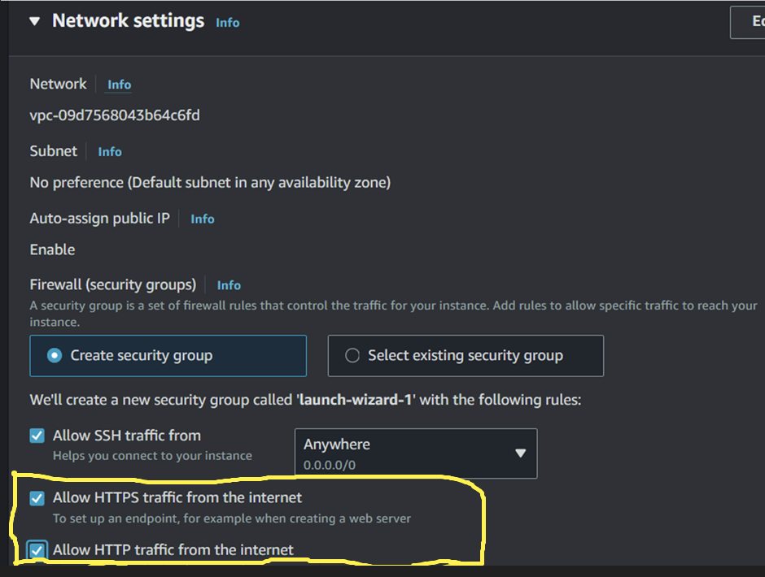

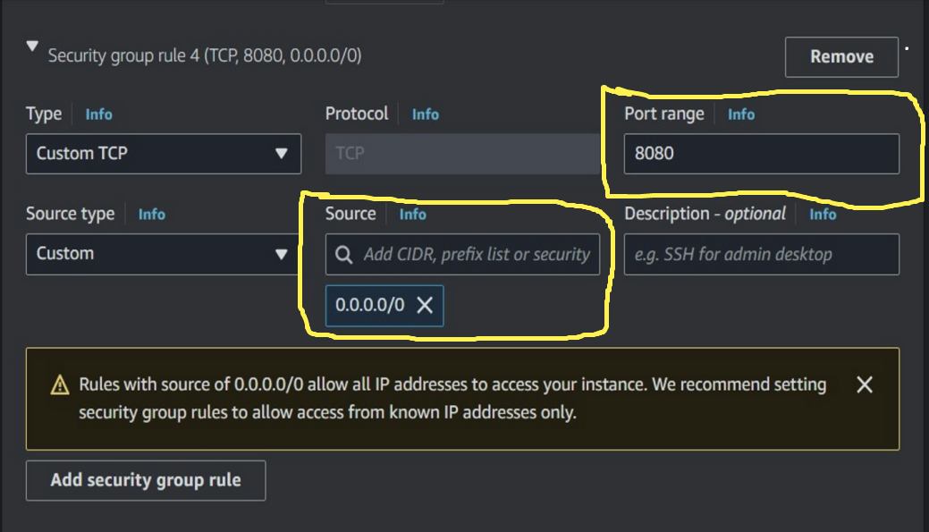

Commands To Install Jenkins   
  
sudo wget -O /usr/share/keyrings/jenkins-keyring.asc \

<https://pkg.jenkins.io/debian-stable/jenkins.io-2023.key>

Then add a Jenkins apt repository entry:

echo deb [signed-by=/usr/share/keyrings/jenkins-keyring.asc] \

https://pkg.jenkins.io/debian-stable binary/ | sudo tee \

/etc/apt/sources.list.d/jenkins.list > /dev/null

Update your local package index, then finally install Jenkins:

sudo apt-get update

sudo apt-get install fontconfig openjdk-17-jre

sudo apt-get install jenkins

After installation need to restart the jenkins…with root user

• systemctl restart jenkins.service

• systemctl start jenkins

• systemctl enable jenkins

• systemctl status jenkins

• To acess the jenkins 🡪 <public ip adress>:8080

Password to enter in Jenkins to start

sudo cat /var/lib/jenkins/secrets/initialAdminPassword